Task 1: Create 5 News Article Pages under /content/us/en/news

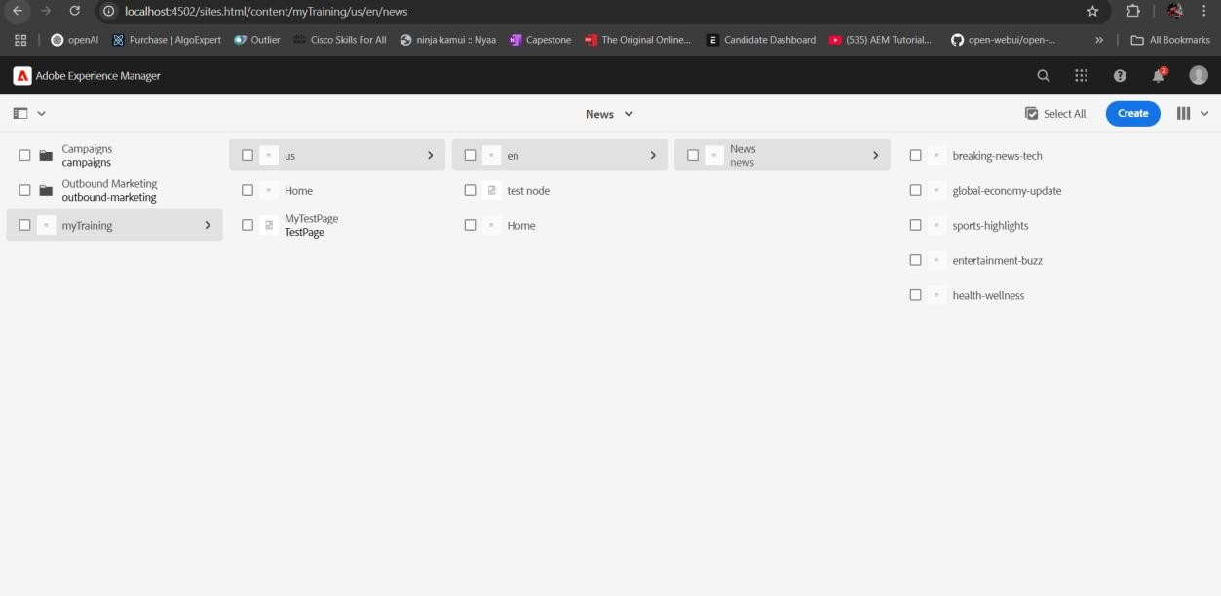

Task 2: Create Header Experience Fragment and Use These Pages as Menu

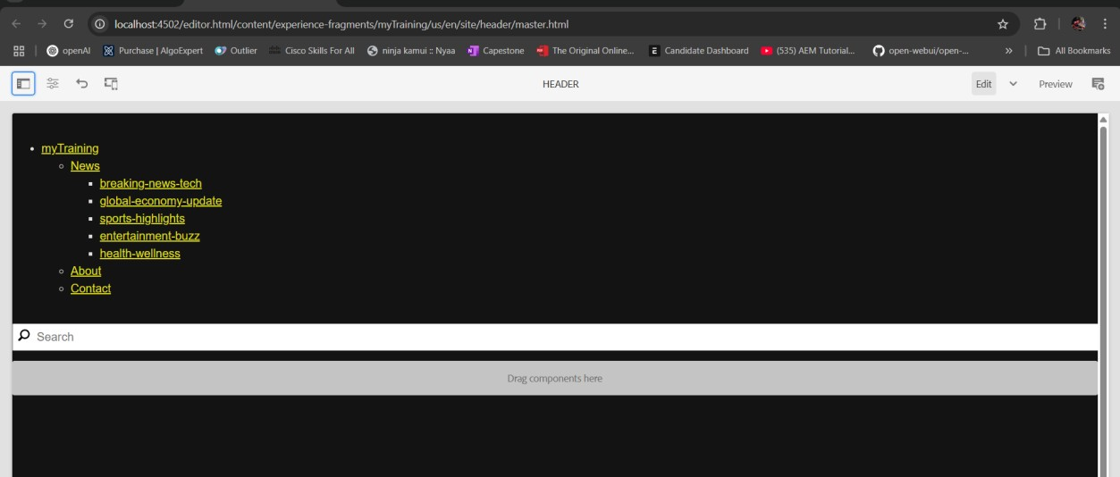

Task 3: Create "Contact Us" and "About Me" Pages

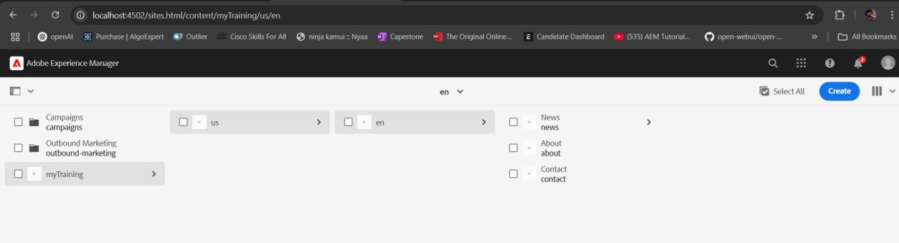

About me page:

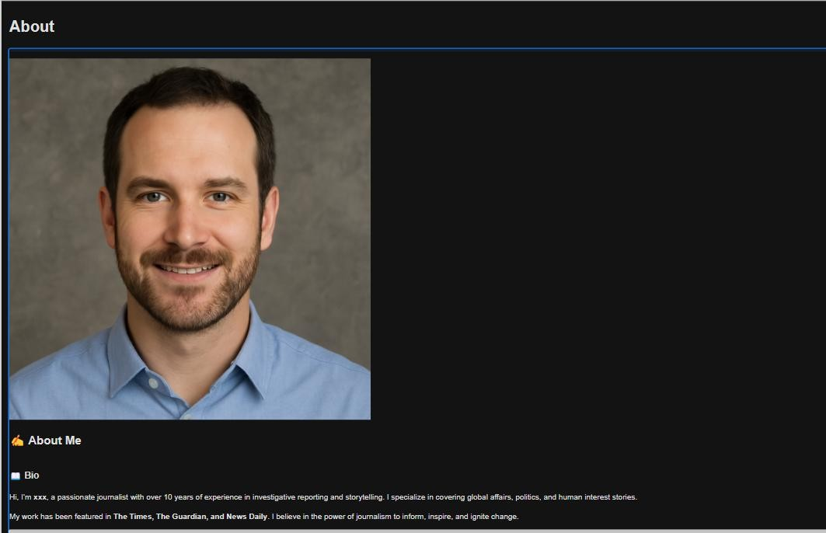

Contact page:

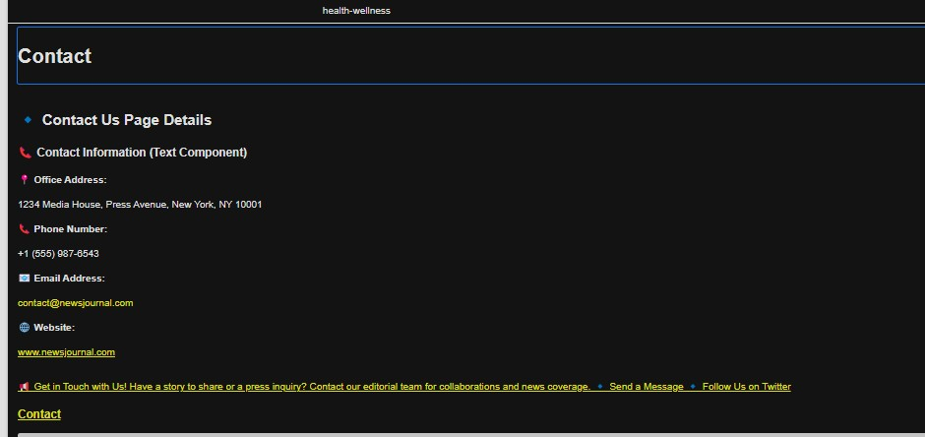

Task 4: Create Footer Experience Fragment with 4 Sections

